**Brief Summary**

Overview of the Project and How it Meets the Requirements:

Our program is a GUI-based program. It imports the three required datasets and allows the user to select two different processes. The first graphs the imported data, generating the required two graphs according to user selected region. The second displays calculated attributes for each country, according to user input.

Because we received permission to do a GUI for this project, there are two modules that we imported that are not detailed in the Final Project Handout. The first is PySimpleGUI, the module that allowed us to create the GUI. The second is os.path which allows for importation of files through file paths using the GUI. In order to run the program, these two modules need to be installed in the virtual environment.

1. Design Process and Planning
   1. Setup of GUI
      1. *Home screen:* Call a simple to understand main screen that allows a user to clearly import and preform functions on data.
      2. *Layout:* Split down the middle, half of the screen will be used as a file browser, the other half will contain commands for the user to execute.
   2. Definition of Key functions
      1. *Search Function*: Define a function that searches the country data list for regions, subregions, countries and returns a list of integer indices that correspond to the selection
      2. *Graph Population Function:* Define a Function that graphs the population density of countries. Takes the list of indices. returned by the search function for input.
      3. *Graph Animal Function*: Define a Function that graphs the number of threatened species per the current population of countries. Takes the list of indices returned by the search function for input.
   3. Creation of Country Class:
      1. Initializes the class country, taking in the index of the country found using the search function as input.
      2. Calculates attributes (data) for the country and attributes them to the class
      3. Defines a function to calculate and display the attributes on the GUI when the user inputs a given country
   4. Main Function:
      1. The main function will serve the purpose of calling on the previously established GUI layout and incorporating events that will call on functions for calculations. In essence, the main function will tie all the other functions and classes together.
2. Task Management and Timeline of Milestones
   1. Large Coding Tasks were divided into two categories:
      1. Coding the GUI and Main Function (Marcos)
         1. Approximate date: December 4
      2. Coding the Functions and Class required for the program (Chris)
         1. Approximate date: December 7
      3. Compilation and Error Checking (Chris and Marcos)
         1. Approximate date: December 9

At the end of the project, the work had been divided approximately 50 / 50 in terms of time spent and lines of code written.

1. Screenshots of successful execution:

Because our program is GUI based, screenshots of terminal output are somewhat irrelevant. We have done our best to emulate the type of informati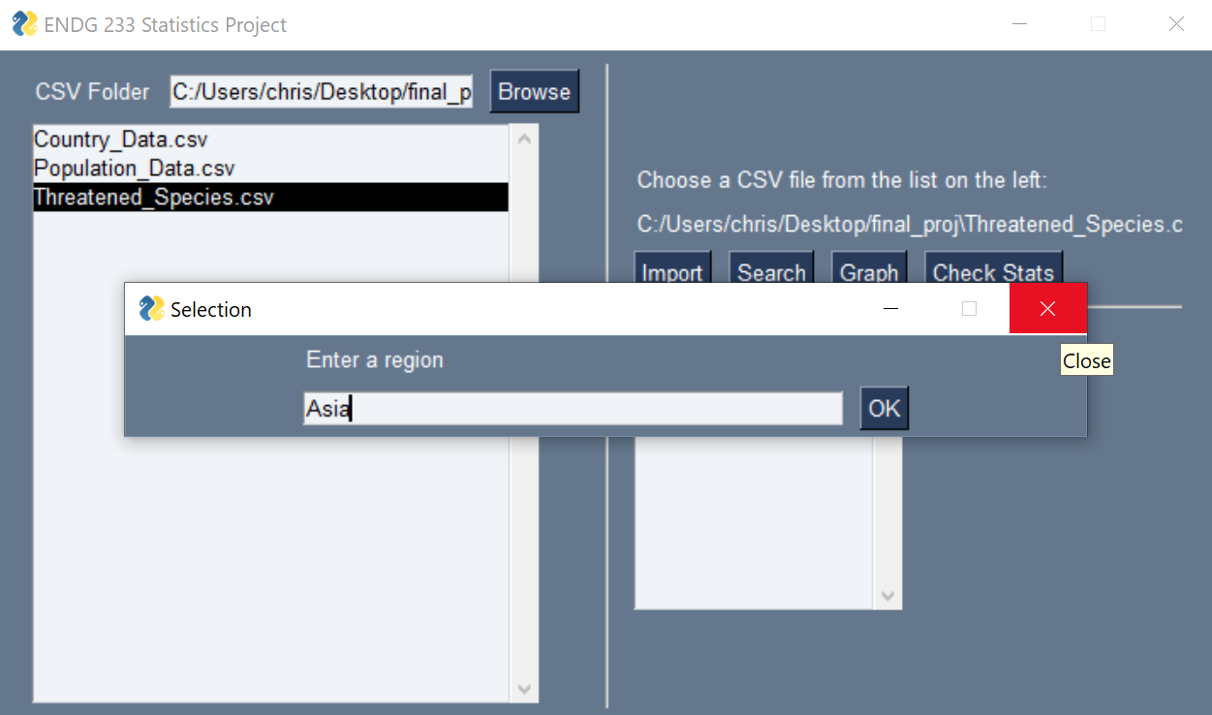on that would usually be included in screenshots below:

Venv is functional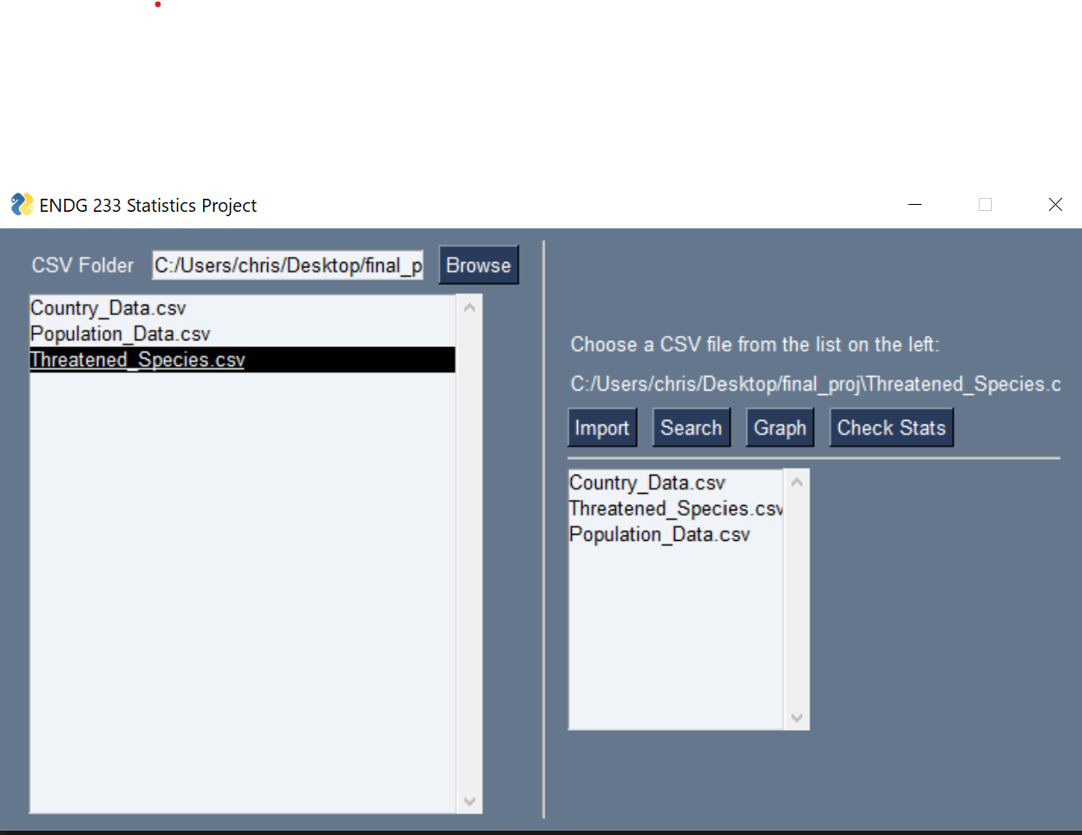

Successful importation of three files:

User input 1 to check stats

User input 2 to check stats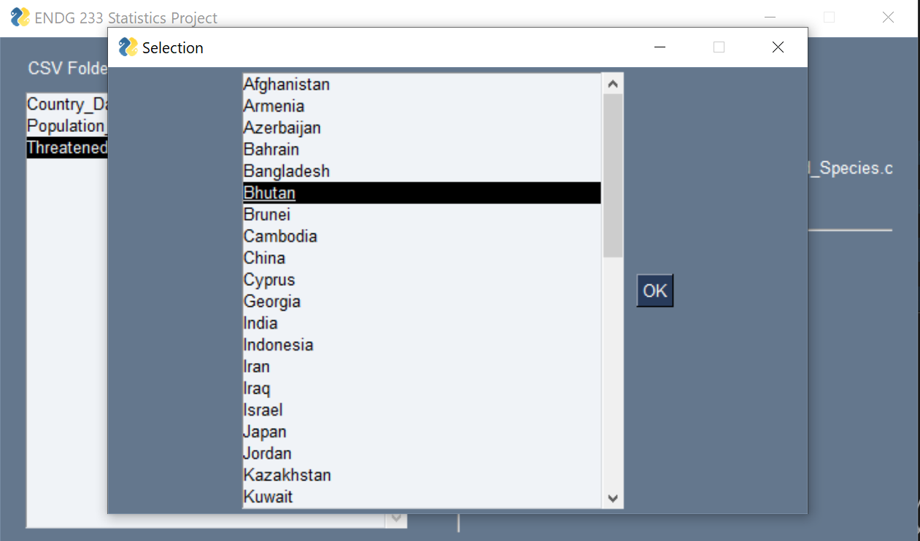

Country Data displayed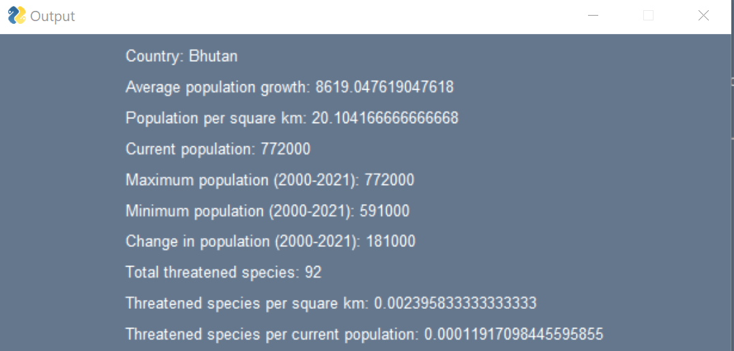

Graphing input 1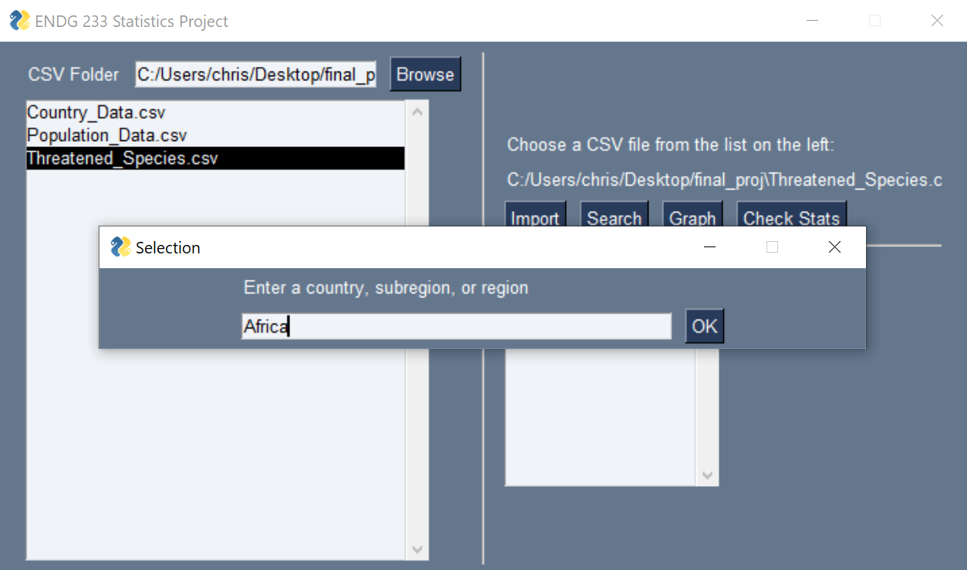

Graphing input 2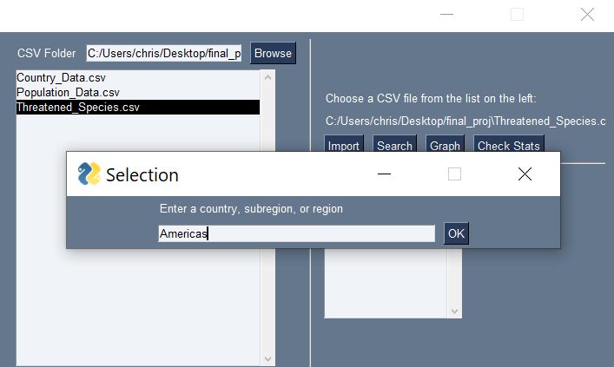

Note: Graphs 1 and 2 are outside of this summary file, but attached in the submitted files as PNG files as requested

Many error messages are displayed if the user does things wrong. There are a lot of these because of the GUI. Here is an example as a screenshot: